**Java variable size:**

Short – 2 byte

Int – 4 byte

Long – 8 byte

Float – 4 byte

Double – 8 byte

Boolean – 1 bit

Char – 2 byte

**Java operators:**

+,-,*,/

**Hello World**

public class java1 {

public static void main(String[] args) {

System.out.print("hello world");

System.out.println("hi");

}

}

**Math operators**

public class math {

public static void main(String[] args) {

int num1 = 5, num2 = 15, num3=2, sum, sub, mul, div;

sum = num1 + num2 + num3;

sub = num1 - num2 - num3;

mul = num1 * num2 * num3;

div = num2 / num1 / num3;

System.out.println(sum);

System.out.println(sub);

System.out.println(mul);

System.out.println(div);

}

}

**Input from the user:**

import java.util.Scanner;

public class input {

public static *void* main(String[] *args*) {

Scanner obj=new Scanner(System.in);

String user;

System.out.println("Enter your name: ");

user = obj.nextLine();

System.out.println("Name is: "+user);

}

}

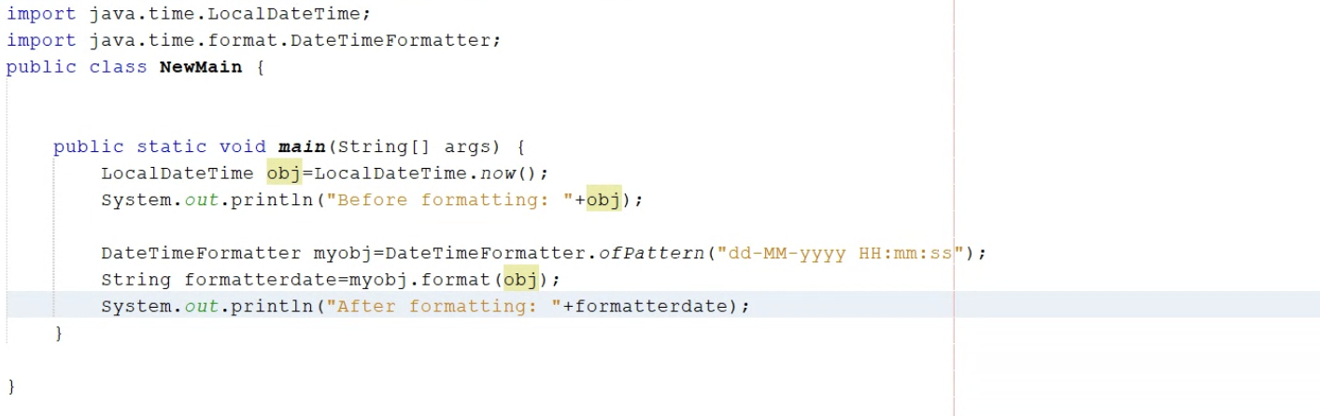

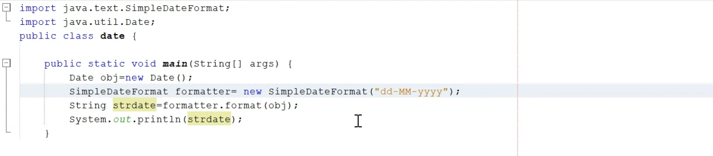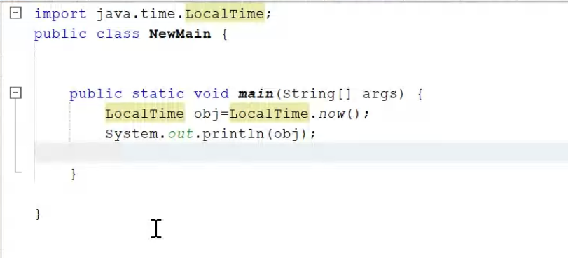 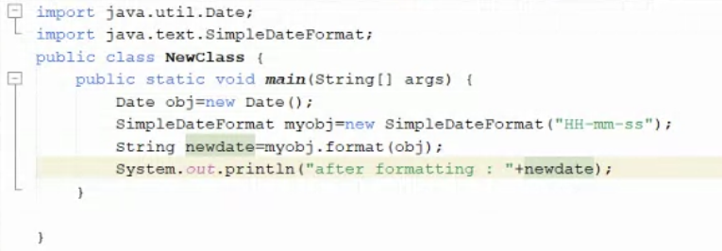

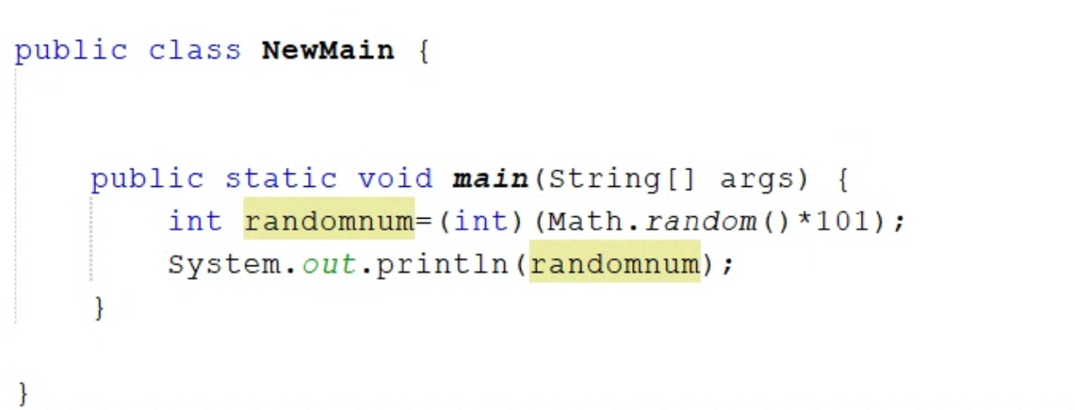

**If-Else Statement:**

import java.util.Scanner;

public class LargestofTwo {

private static Scanner sc;

public static *void* main(String[] *args*)

{

*int* number1, number2;

sc = new Scanner(System.in);

System.out.print(" Please Enter the First Number : ");

number1 = sc.nextInt();

System.out.print(" Please Enter the Second Number : ");

number2 = sc.nextInt();

if(number1 > number2)

{

System.out.println("\n The Largest Number = " + number1);

}

else if (number2 > number1)

{

System.out.println("\n The Largest Number = " + number2);

}

else

{

System.out.println("\n Both are Equal");

}

}

}

**Predefined and user defined:**

Predefined:

User defined:

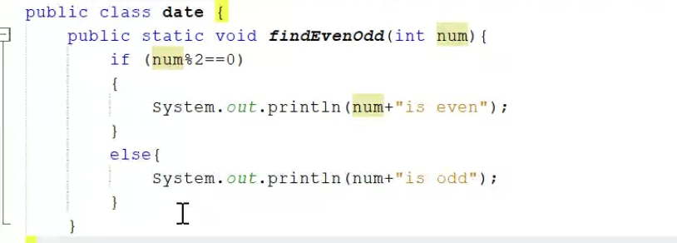

Calling User defined Function:

